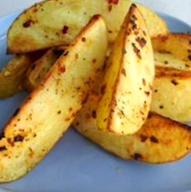
Potato wedges
Ingredients
3 large potatoes
Spray oil
Chilli flakes
Black pepper

Serves 4
Equipment
Chopping board, sharp knife, measuring spoon, mixing bowl, mixing spoon, baking tray.

Method
- Preheat the oven to 200ºC or gas mark 6.
- Cut potatoes into wedges. Put into a mixing bowl.
- Spray the oil on the wedges and add the chilli and black pepper.
- Mix.
- Place on baking tray and bake for 20-30 minutes.

Eat well for you and the planet! Top tips
- Focus on fibre – keep the skin on your potatoes for added fibre.
- Get at least 5 A DAY – swap the potatoes for sweet potatoes, carrots, or parsnips.
- Reduce food waste – make potato skin crisps! Use the peeled skin of potatoes, carrots and parsnips to make crisps. Pat the skins dry and spread on a large baking tray. Spray lightly with oil and season with pepper. Bake in the oven (200ºC) until crisp, about 15-18 minutes. Vary the flavour by tossing in fresh or dried herbs, spices such as smoked paprika or cumin, or garlic and onion powder immediately after baking.

