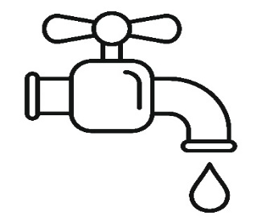
Water tracker
Add a blue dot to the water jug every time you have a cup of tap water.

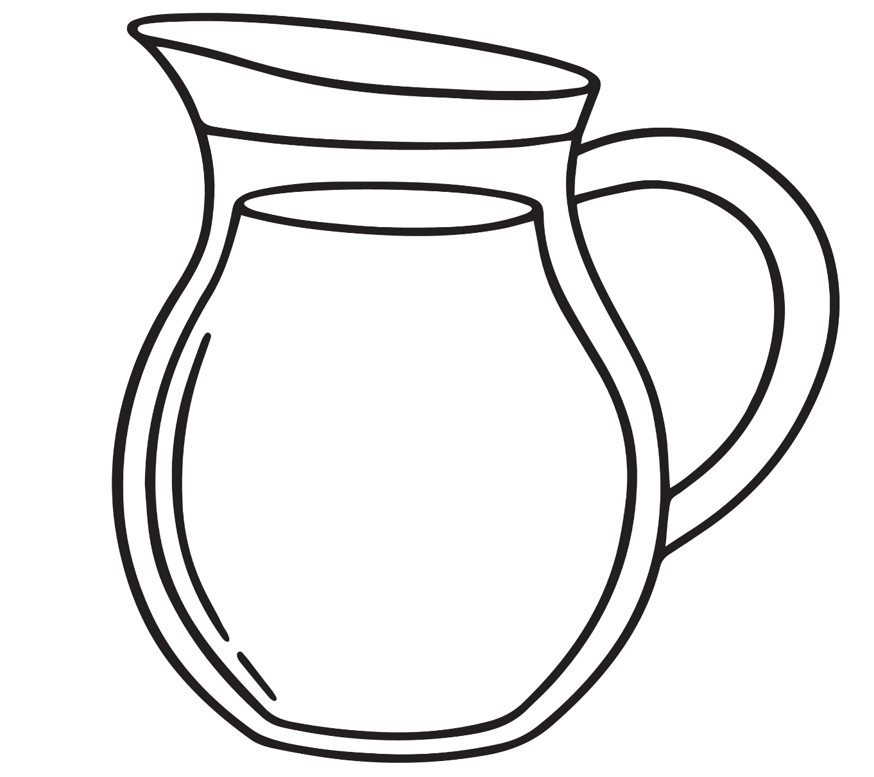

How many cups of tap water did you have?

