# **Green mac and cheese**

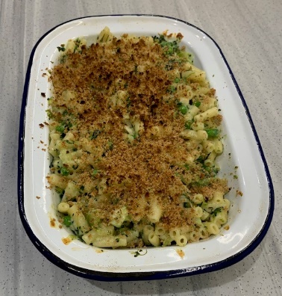**Ingredients**

200g macaroni or another type of pasta

200g fresh or frozen broccoli florets

25g butter or reduced-fat spread

25g plain flour

275ml semi-skimmed milk

½ x 5ml mustard*

50g spinach, chopped (fresh, or defrosted and excess water squeezed out)

75g peas (fresh or frozen)

100g reduced-fat cheese

Black pepper

**Serves 3-4**

100g breadcrumbs (optional)

**\***if you are allergic to mustard, use paprika or cayenne pepper as an alternative.

**Equipment**

Two saucepans, colander, measuring jug, mixing spoon, grater, chopping board or plate.

**Method**

1. Bring a saucepan of water to the boil, and then add the macaroni. Cook for about 10 – 12 minutes, until *al dente*. About 5 minutes before the pasta is cooked, add the broccoli florets to the pan. Once cooked, drain and place in an oven proof dish.
2. While the pasta is cooking, make the sauce:

* place the fat, flour and milk into a saucepan;
* bring the sauce to a simmer, whisking all the time until it has thickened.

1. Once the sauce is thick, mix in the spinach, peas and mustard. Turn down the heat and simmer for approximately 5 minutes. If the sauce becomes too thick, add a little more milk.
2. Grate the cheese and add three quarters to the sauce and stir well. The heat of the sauce will melt the cheese.
3. Pour the mixture over the pasta and broccoli. Season with black pepper and mix well.
4. Sprinkle over the remaining cheese and the breadcrumbs, if using.
5. Place under a hot grill until the cheese is bubbling and the breadcrumbs are golden brown.

**Top tips**

* Focus on fibre – use wholewheat pasta to give your mac and cheese a fibre boost.
* Get at least 5 A DAY – try cauliflower instead of broccoli or add a large handful of frozen sweetcorn. Make ribbons of courgette with a peeler and add to the sauce with the cheese.
* Vary your protein – add canned tuna (in spring water), cooked chicken or chopped ham.
* Reduce food waste – save any leftovers for a quick and easy lunch!