Hydration station set up guide
We all need to stay hydrated during the day. Why not try setting up a hydration station in the classroom to encourage everyone to drink more water?

Setting up a hydration station

Equipment
- Jugs or other suitable water containers
- Glasses or recyclable cups

Ingredients
- Fridge chilled water
- Fruit, e.g. strawberries, orange, lemon and lime slices
- Vegetables, e.g. cucumber, celery
- Herbs, e.g. mint, basil

Optional:
- Ice
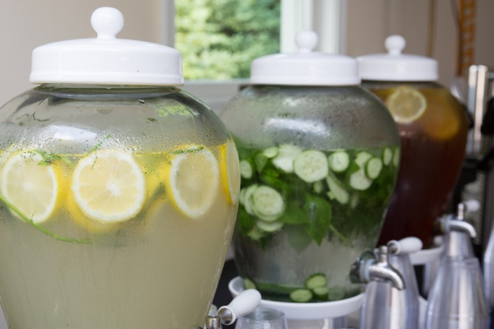

Get creative with your infusions!

Did you know that being dehydrated can make it difficult to concentrate and may cause headaches and tiredness?

Aim to have around 6 to 8 drinks (glasses or cup of fluid) a day – more if the weather is warm or you are being active.

