# Name ____________________

# **Colourful pulses** Colour each pulse correctly. Draw some other foods that are the same colour.

Other foods this colour

Chickpeas

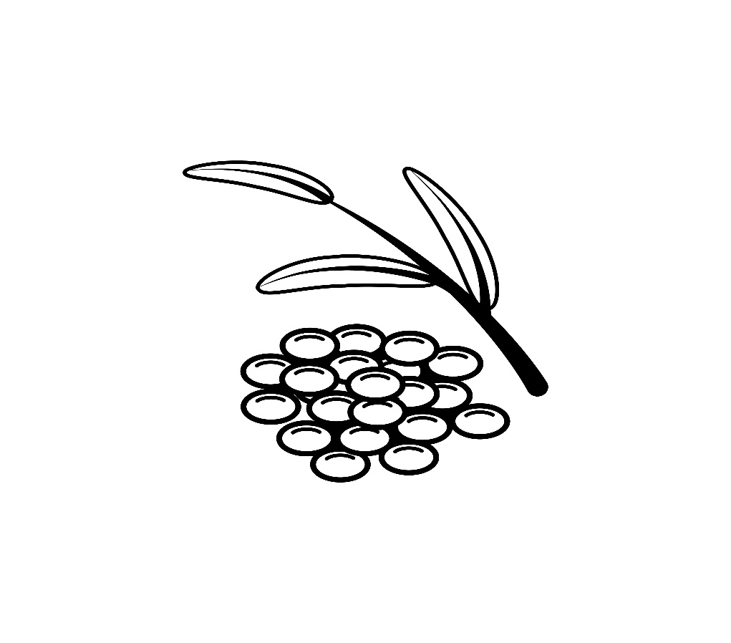

Green lentils

Other foods this colour

Other foods this colour

Red kidney beans