# Name ___________________

# **Perfect pulses!** Find each pulse and colour it correctly. Fill in the missing letter in the name of each pulse.

Black e__ed beans

Chi__kpeas

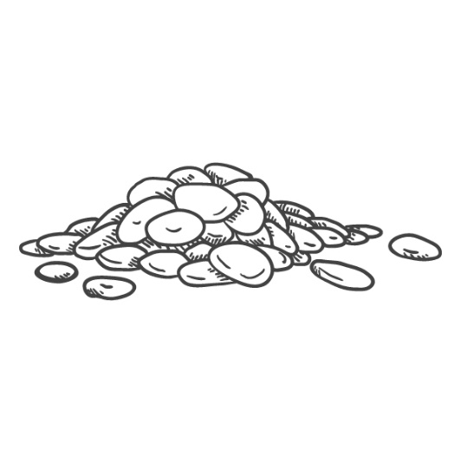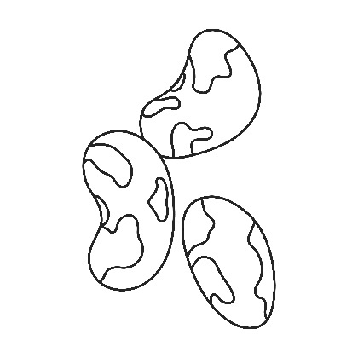

Pint__ beans

Red kidney bea__s

G__een lentils

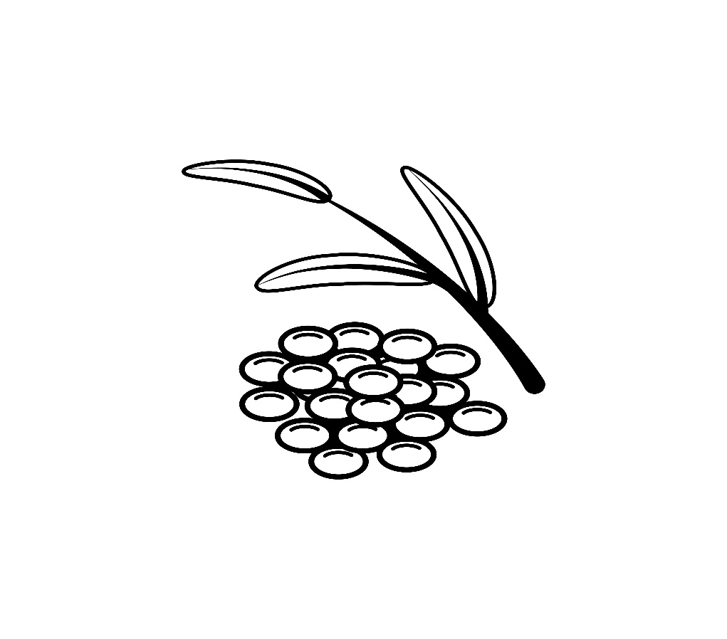

Red lentil__