Vary your protein tracker
Keep track of how many different protein foods you have this week. We should eat a variety of different protein foods.
Day | Protein foods eaten
Monday
Tuesday
Wednesday
Thursday
Friday

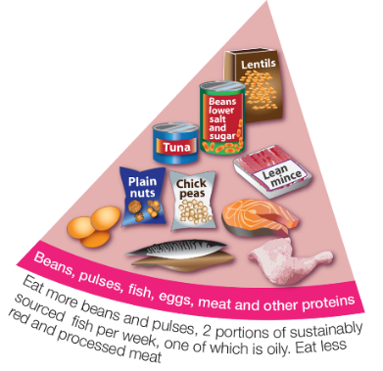
How many different protein foods did you have?

How many were from plants?

What other protein foods could you try?

