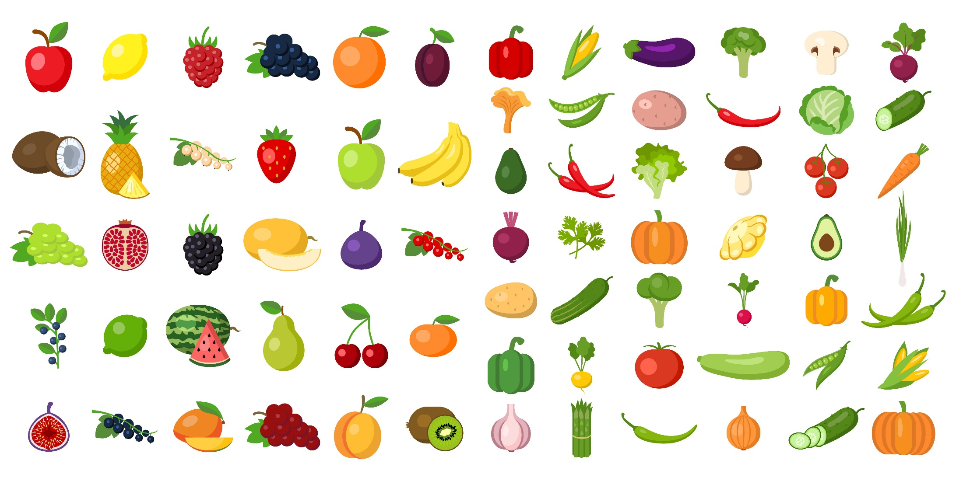
Find the fruit and vegetables

How many are red? | Where is the kiwi fruit?
Which are shaped like circles? | Name all the green vegetables.
Name the two you like best. | Where is the lettuce?
How many are purple? | Which ones have stalks?

