Mushroom and chickpea curry
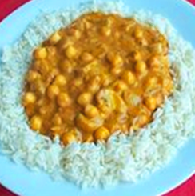
Ingredients
1 onion
1 clove garlic
100g mushrooms
2 x 15ml spoons (2 tablespoons) curry paste
2 x 15ml spoons (2 tablespoons) tomato puree
200g canned chickpeas (rinsed and drained)
1 can coconut milk
1 x 15ml spoon (1 tablespoon) oil
Serves 2

Equipment
Chopping board, sharp knife, weighing scales, saucepan, garlic press, wooden spoon, measuring jug, measuring spoons, colander, can opener.

Method
- Prepare the ingredients:
- peel and chop the onion;
- slice the mushrooms;
- peel and crush the garlic using a garlic press.
- Heat the oil in a saucepan and fry the onion, garlic and mushrooms for 5 minutes.
- Stir in the curry paste and tomato puree.
- Add the chickpeas and coconut milk.
- Simmer gently for 20 minutes.
- Serve with rice and/or naan bread.

Eat well for you and the planet! Top tips
- Focus on fibre – serve with brown rice for a fibre boost.
- Get at least 5 A DAY – add more vegetables such as chopped green, red or yellow peppers, grated courgettes, tomatoes or butternut squash.
- Vary your protein – use a can of lentils in water, instead of chickpeas.
- Reduce food waste – freeze leftover curry paste. Spray an ice cube tray lightly with oil (this will prevent staining). Fill the trays with paste and freeze until completely frozen (about 2 hours). Once frozen remove from the trays and place in a bag in the freezer. By freezing them individually first, they won’t stick together. They can then be used as and when needed.

