# **Bean and plantain stew**

**Ingredients**

1 small onion

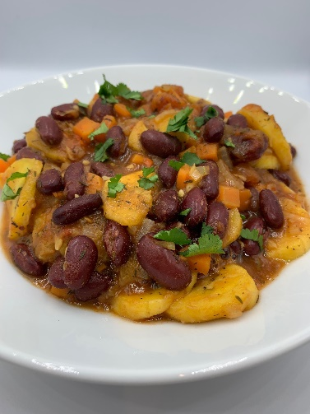1 carrot

1 celery stick

1 clove garlic

1/8th scotch bonnet chilli or ½ x 5ml spoon chilli flakes

1 plantain

400g kidney beans

spray oil

200g canned chopped tomatoes

1 vegetable stock cube

125ml water

1 x 15ml spoon dried thyme

**Serves 2**

½ x 15ml spoon All purpose seasoning

Black pepper

Optional - garnish

25g parsley

**Equipment**

Chopping board, vegetable knife, garlic press, colander/sieve, large saucepan, mixing spoon, measuring jug, measuring spoons.

**Method**

1. Prepare the ingredients:

* peel and finely dice the onion;
* peel and finely dice the carrot;
* finely dice the celery;
* peel and finely chop or crush the garlic;
* deseed and finely chop the scotch bonnet, if using;
* peel and slice the plantain;
* drain and rinse the kidney beans;
* roughly chop the parsley, if using.

1. Spray the saucepan with oil and add the onion, carrot, celery, garlic and the fresh or dried chilli.
2. Fry gently for 3-4 minutes.
3. Add the plantain, kidney beans and chopped tomatoes.
4. Crumble over the stock cube and add the water.
5. Bring to the boil and add the dried thyme and All purpose seasoning. Season with black pepper.
6. Reduce the heat and simmer for 10 minutes, until the plantain is soft.
7. Serve sprinkled with chopped parsley, if using.

**Top tips**

* Get at least 5 A DAY – the plantain in this recipe can be replaced with a large unripe banana, a potato, yam, sweet potato or breadfruit, or canned jackfruit. Additional cooking time may be required, particularly if using potato or sweet potato.
* Vary your protein – serve with basa (fresh or frozen) or another fish from a sustainable source. Refer to the [Good Fish Guide](https://www.mcsuk.org/goodfishguide/) for further information.
* Reduce food waste – freeze any leftover garlic cloves. Peel and freeze the cloves in a freezer-proof container. Remove when needed and grate, crush or chop and add to recipes.