# **Track my fibre**

Did you know? A food is a ‘source of’ fibre if it has at least 3g fibre per 100g,   
and ‘high in’ fibre if it has more than 6g per 100g? Did you have any ‘high in’ fibre foods today? Track your fibre and find out!

|  |  |  |  |
| --- | --- | --- | --- |
| Occasion | Food | Fibre per 100g | Is it high in fibre? |
| Breakfast |  |  |  |
| Lunch |  |  |  |
| Evening meal |  |  |  |
| Snacks |  |  |  |

My fibre total today is

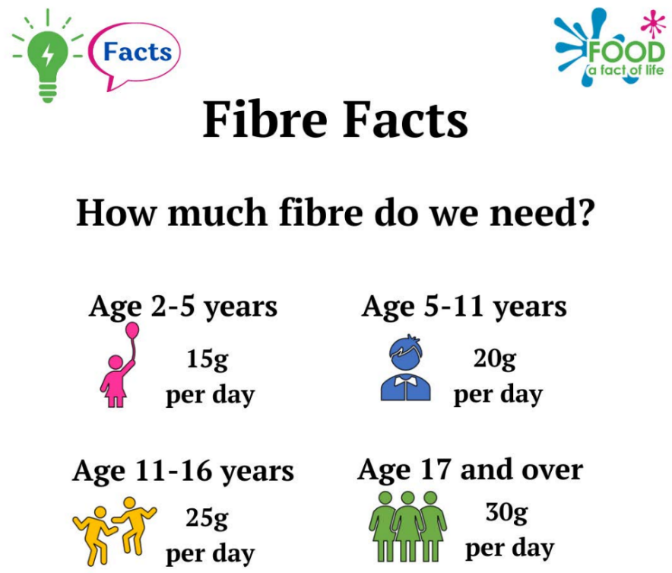

**g**

How can I find the fibre?

The fibre content of food is often found on the food label, so take a look!

No information? No food label?

Use our free nutritional analysis tool, Explore Food, to find out: [**https://bit.ly/3FiWoT2**](https://bit.ly/3FiWoT2)

You’ll just need to know the weight of the food.