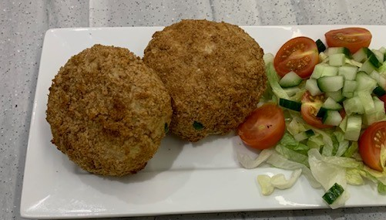
Fabulous fish cakes
Ingredients
250g potatoes
40g of fresh or dried breadcrumbs (1 slice of bread) or 4 oatcakes
100g canned fish, e.g. tuna in spring water
60g frozen or canned mixed vegetables
1 x 5ml spoon dried herbs, e.g. parsley or dill
Black pepper
1 egg
Serves 2
Equipment
Baking tray, vegetable peeler, vegetable knife, chopping board, saucepan, food processor or food bag, plate, large mixing bowl, colander, fork or potato masher, mixing spoon, small bowl.

Method
- Preheat oven to 220°C or gas mark 7.
- Grease or line a baking tray.
- Peel and chop the potato.
- Place chopped potatoes in a pan of cold water. Bring to the boil and cook until soft, approximately 10-12 minutes.
- Blitz the slice of bread in a food processor, if making fresh breadcrumbs, or crush the oat cakes in a food bag, and tip onto a plate.
- Drain the tuna and place in a large mixing bowl.
- Drain the cooked potatoes and add to the bowl with the tuna.
- Mash with a fork or a potato masher.
- Add the mixed vegetables and herbs. Mix well and season with black pepper.
- Divide the mixture into four.
- Shape each portion into a cake (or a fish).
- Crack the egg into a bowl and mix with a fork.
- Dip a fishcake into the egg and then roll in the breadcrumbs or oatcakes to cover.
- Place on the baking tray.
- Bake for 15-20 minutes. Alternatively, cook in an air-fryer until golden, approximately 10 minutes.

Top tips
- Focus on fibre – use wholemeal bread for your breadcrumbs to give the fishcakes a fibre boost. Bread that is slightly stale is great for making breadcrumbs, rather than ending up in the food waste bin.
- Get at least 5 A DAY – use canned vegetables instead of frozen.
- Vary your protein – try canned salmon or crab or frozen fish also works well (cook frozen fish before using). Ensure that you use fish from a sustainable source. Refer to the Good Fish Guide for further information.
- Reduce food waste – use leftover mashed potato.

