Hydration station set up guide
We all need to stay hydrated during the day. Why not try setting up a hydration station in your setting to encourage everyone to drink more water?

Setting up a hydration station

Equipment
- Jugs or other suitable water containers
- Reusable cups

Ingredients*
- Fridge chilled water
- Fruit, e.g. strawberries, melon, orange, lemon and lime slices
- Vegetables, e.g. cucumber, celery
- Herbs, e.g. mint, basil

* Remember to check for allergies, intolerances, or special dietary requirements before choosing ingredients for the hydration station. Use large pieces of fruit and vegetables to reduce the risk of choking.

Optional
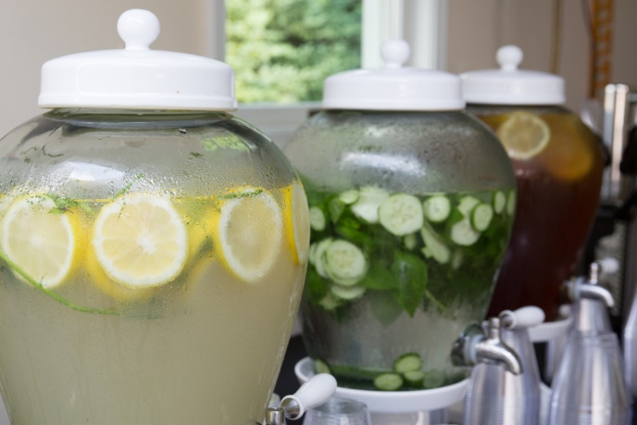
- Ice

Get creative with your infusions!

Did you know that being dehydrated can make it hard to concentrate and may cause headaches and tiredness?

Aim to have around 6 to 8 drinks (glasses or cup of fluid) a day – more if the weather is warm or you are being active.

