# Name ___________________

# **Perfect pulses!** Find each pulse and colour it correctly. Fill in the missing letter in the name of each pulse.

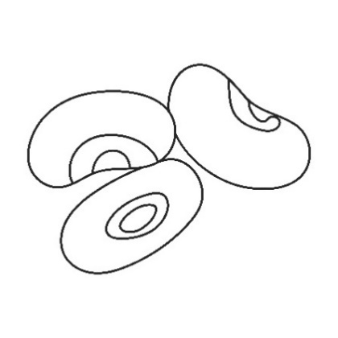

Black e__ed beans

# 

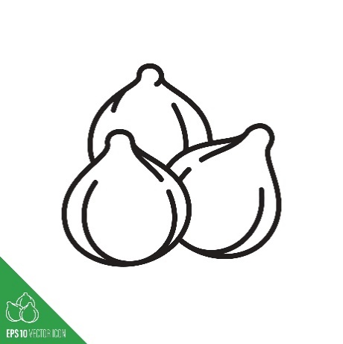

Chi__kpeas

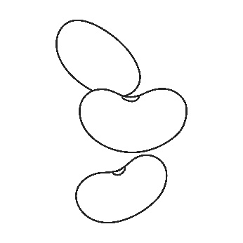

Red kidney bea__s

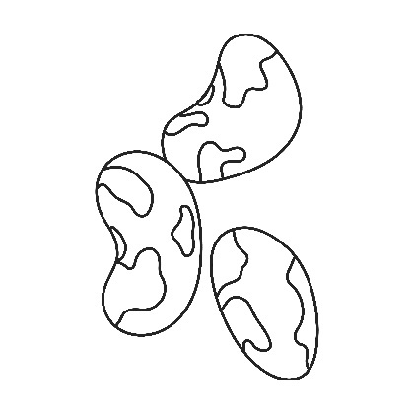

Pint__ beans

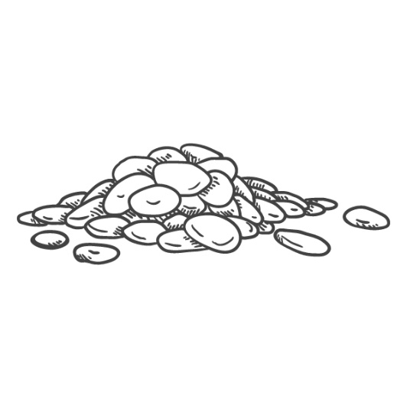

Red lentil__

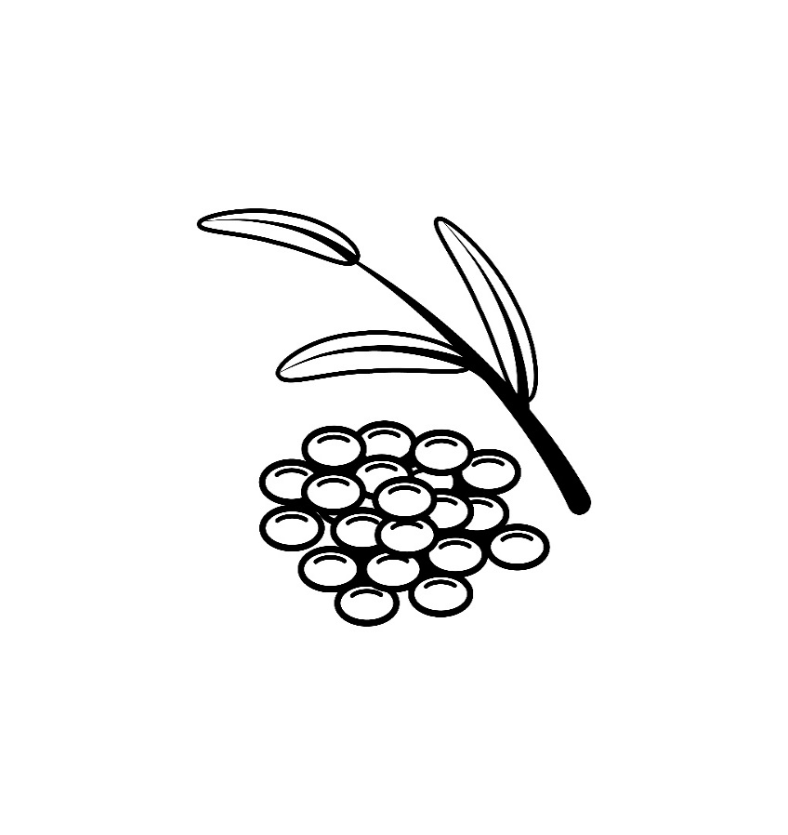

G__een lentils