Your portion wise tracker
Meal | Foods included | 5+ | 3-4 | 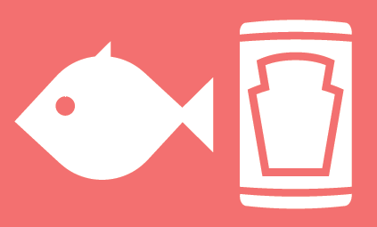  2-3 | 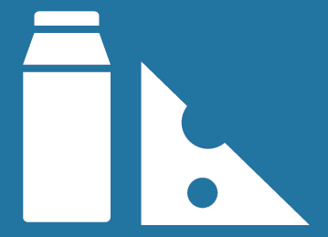  2-3
Breakfast | Example: Wholegrain cereal and milk | ☐ | ☒ | ☐ | ☒
 |  | ☐ | ☐ | ☐ | ☐
 |  | ☐ | ☐ | ☐ | ☐
 |  | ☐ | ☐ | ☐ | ☐
Morning snack |  | ☐ | ☐ | ☐ | ☐
Lunch |  | ☐ | ☐ | ☐ | ☐
 |  | ☐ | ☐ | ☐ | ☐
 |  | ☐ | ☐ | ☐ | ☐
Afternoon snack |  | ☐ | ☐ | ☐ | ☐
Evening meal |  | ☐ | ☐ | ☐ | ☐
 |  | ☐ | ☐ | ☐ | ☐
 |  | ☐ | ☐ | ☐ | ☐
Total daily portions
Use this tracker with our Your balanced diet - get portion wise! guides available on www.nutrition.org.uk. A balanced diet is about having the right types of foods and drinks in the right amounts for you. Aim for at least 5 portions of fruit and vegetables, 3-4 of starchy foods (choose wholegrains), 2-3 of protein (include some plant sources), 2-3 of dairy (or dairy alternatives) and include some unsaturated fats (like olive or rapeseed oil).

