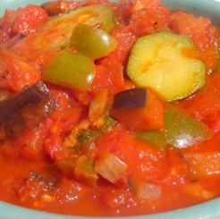
Ratatouille
Ingredients
1 onion
1 clove garlic
1 small aubergine
1 green pepper
1 courgette
1 handful fresh basil
Spray oil
2 cans chopped tomatoes (800g)
Serves 4 as an accompaniment

Equipment
Chopping board, knife, garlic press, saucepan, measuring spoons, wooden spoon, can opener.

Method
- Prepare the vegetables:
- peel and chop the onion;
- peel and crush the garlic;
- dice the aubergine;
- de-seed and chop the green peppers;
- slice the courgette;
- tear the basil leaves.
- Fry the onion and garlic in the oil for 5 minutes.
- Add the aubergine and fry for a further 5 minutes.
- Add the pepper, courgette and tomatoes.
- Stir-in the torn basil leaves.
- Bring to the boil and then simmer gently, with the lid on the saucepan, for 20-30 minutes.

Eat well for you and the planet! Top tips
- Focus on fibre – serve this dish with some brown rice to boost the fibre content.
- Get at least 5 A DAY – try using more or different vegetables, such as mushrooms or green beans, to add to the variety of vegetables to the dish!
- Vary your protein – add some pulses, such as beans or chickpeas.
- Reduce food waste – use up any vegetables that may otherwise go to waste. Freeze leftover basil in ice cube containers for another day.

