# **Fibre hunt**

## Look at the labels on different foods and find out how much fibre they contain.

|  |  |
| --- | --- |
| **Food** | **Fibre per 100g** |
|  |  |
|  |  |
|  |  |
|  |  |
|  |  |

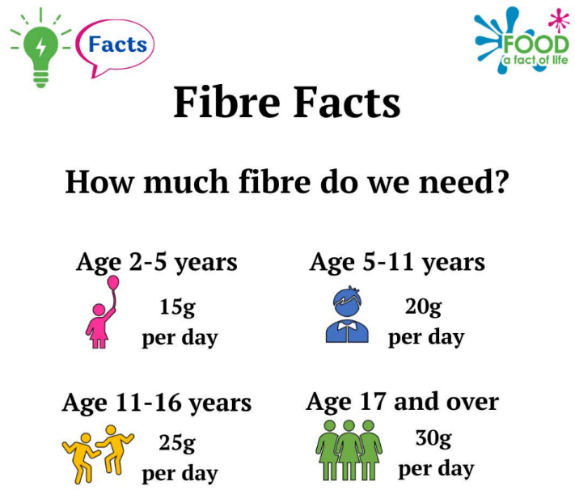

Which food has the most fibre   
per 100g? _____________________________

What two things do you notice about the   
amount of fibre in different foods?

______________________________________

______________________________________

**Extension task**

Looking at the fibre in 100g of each food helps us to compare the foods fairly, but we don’t always eat 100g of every food.

Choose three foods. Work out the amount you would usually eat and how much fibre it would contain.

|  |  |  |
| --- | --- | --- |
| **Food** | **Amount I would have (g)** | **Fibre** |
|  |  |  |
|  |  |  |
|  |  |  |