# Name ____________________

# **Colourful pulses** Colour each pulse correctly. Draw some other foods that are the same colour.

# 

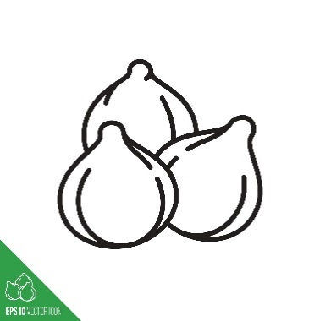

Chickpeas

Other foods this colour

Other foods this colour

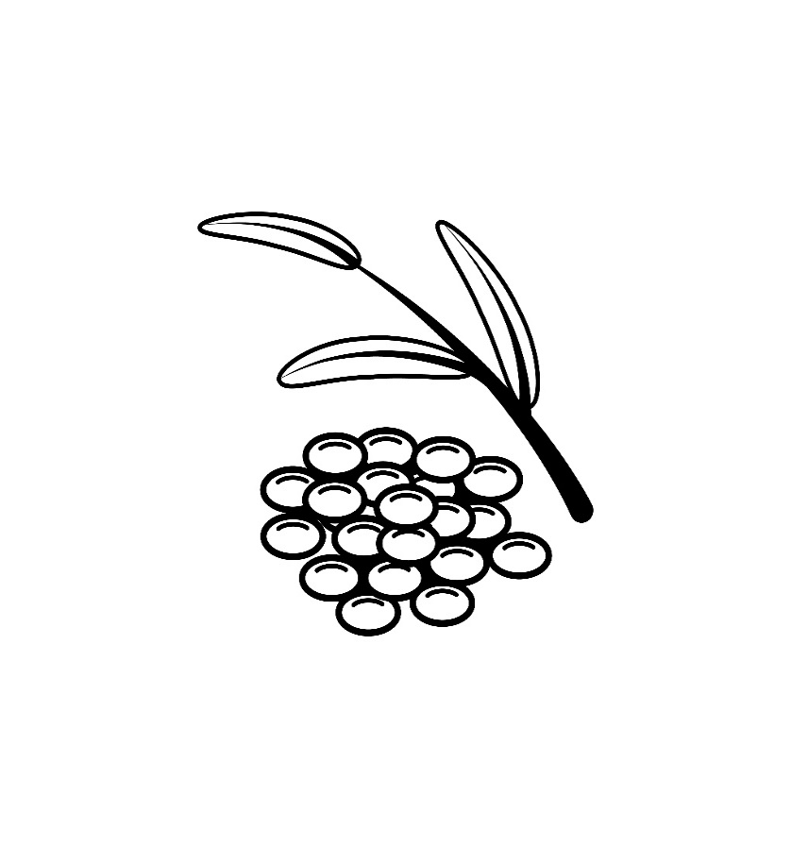

Green lentils

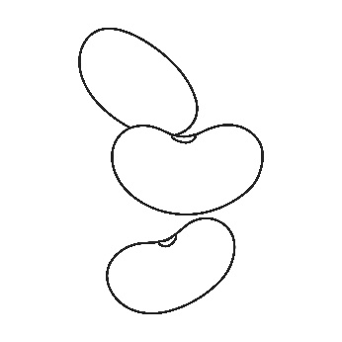

Red kidney beans

Other foods this colour