Vegan Potato Cakes

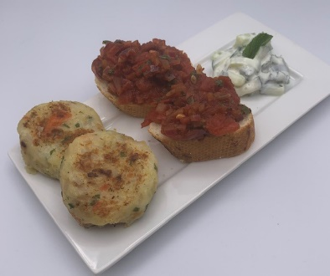
Ingredients:
450g potatoes
1 small onion
50g canned sliced carrots in water
25g parsley
100g easy cook rice
2 x 5ml spoon olive oil
Black pepper

Matthew recommends this his potato cakes are served with
tomato-topped crusty bread and a chunky yogurt dip

Tomato-topped crusty bread
½ small red onion
2 garlic cloves
6-8 basil leaves
1 small crusty loaf
400g can chopped tomatoes
30ml balsamic vinegar
1 x 5ml spoon olive oil

Chunky yogurt, cucumber and mint dip
¼ cucumber
Mint leaves (approx. 10 depending on size)
100g reduced fat natural yogurt
¼ x 5ml spoon cumin

Equipment
Peeler, vegetable knife, chopping board, large saucepan, potato masher, colander, small saucepan, measuring spoon, frying pan x 2, heat proof spoon, mixing bowl x 2, mixing spoon, bread knife.

Method
- Prepare the ingredients:
  - peel and quarter the potatoes;
  - peel and dice the onion;
  - drain and roughly chop the carrots;
  - chop the parsley.
- Place the potatoes in a saucepan and cover with cold water. Bring to the boil and cook until they are tender, approximately 10 minutes.
- Drain and mash the potatoes.
- Rinse the rice and place in a pan of boiling water. Cook until soft, approximately 10 minutes.
- Drain the rice once cooked.
- Heat the oil in a frying pan and gently fry the onion and carrot until they are soft, but not coloured.

- In a bowl combine the mashed potatoes with the rice, onions, carrots and parsley. Season with black pepper.
- Divide the mixture into 8 equal portions and shape into circles in your hands.
- Heat 1 x 5ml spoon olive oil in the frying pan and gently cook the potato cakes until they are golden brown.

Method – tomato-topped crusty bread
- Prepare the ingredients:
  - peel and dice the onion;
  - peel and crush or chop the garlic;
  - roughly chop the basil leaves;
  - thickly cut the crusty bread;
  - drain the canned tomatoes to remove most of the juice.
- Heat the oil in a frying pan and add the onion and garlic. Gently fry for 3-4 minutes until soft, but not coloured.
- Add the drained tomatoes and basil leaves and cook for a further 5 minutes.
- Toast or grill the bread, if desired, and top with the tomato mixture.

Method – chunky yogurt, cucumber and mint dip
- Prepare the ingredients:
  - roughly chop the cucumber;
  - roughly chop the mint.
- Place the cucumber and mint in a mixing bowl and add the yogurt and cumin. Mix to combine.

Matthew’s top tips:
- Add grated cheese to add protein and calcium (if not vegan).
- To save money use canned and frozen vegetables. Buy big bags of rice on special offer.
- Roast the potato peelings in the oven with a little spray oil and seasoning for a fun alternative to traditional potato crisps!

