Butter bean dip
Ingredients
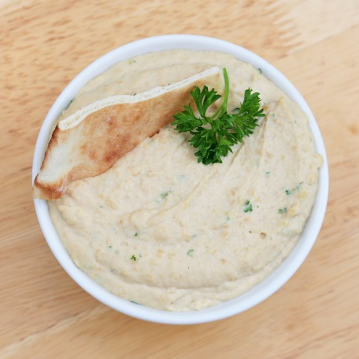
1 x 400g can butter beans
1 lemon
1 clove of garlic
1½ x 15ml spoons (1 ½ tablespoons) olive oil
A little water

Equipment
Sieve, blender, sharp knife, chopping board, lemon
squeezer, measuring spoons, garlic press, spatula,
can opener, serving dish.

Method
- Drain the butter beans and place into the blender.
- Cut the lemon in half. Squeeze the lemon and add the juice to the blender.
- Peel the garlic and add to the blender along with the olive oil.
- Place the lid on the blender and switch on for 15 - 20 seconds.
- Turn the blender off and unplug at the wall. Use a spatula to move the butterbeans away from the edge of the blender. Add a little water as required,
- Place the lid on the blender and switch on for 15-20 seconds.
- Repeat stages 5-6 until a smooth paste is produced.
- Serve.

Eat well for you and the planet! Top tips
- Focus on fibre – serve with homemade quick flatbreads. Mix 150g wholemeal self-raising flour with 150g low fat natural yogurt and season with black pepper. Mix to form a soft dough then divide into four and flatten into circles. Dry fry the flatbreads in a non-stick pan until they are crisp and golden, approximately 3 minutes on each side.
- Get at least 5 A DAY - top with a mixture of chopped tomatoes, crushed garlic, chopped parsley, chopped fresh chilli and lemon juice.
- Vary your protein – try canned broad beans instead of butter beans.
- Reduce food waste – use 1 x 5ml spoon (1 teaspoon) ready-prepared garlic from a tube or jar instead of fresh garlic. This can be stored in the fridge to be used whenever needed.

