Basic tomato sauce
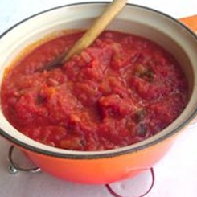
Ingredients
1 onion
1 clove of garlic
Handful of fresh basil or 1 x 15ml spoon (1 tablespoon) dried herbs
Spray oil
2 large cans (800g) chopped tomatoes
Black pepper
75g dried pasta per person
Serves 4

Equipment
Knife, chopping board, garlic press, two saucepans, wooden spoon, colander.

Method
- Prepare the ingredients:
- peel and finely dice the onion;
- peel and crush the garlic;
- chop the basil.
- Heat the oil and fry the onion and garlic for 5 minutes, until soft.
- Add the tomatoes, basil and pepper.
- Allow to simmer gently for 30 minutes (longer if possible).
- Cook the pasta following the instructions on the packet.
- Drain the pasta and serve with the tomato sauce.

Eat well for you and the planet! Top tips
- Focus on fibre – use wholewheat pasta to give this dish a fibre boost.
- Get at least 5 A DAY – add extra vegetables such as grated carrots or courgettes, or sliced mushrooms.
- Vary your protein – add a mixture of lean beef mince and a plant source of protein like beans, soya mince or a mycoprotein-based meat alternative (e.g. vegetarian mince) to create a bolognese. Add the mince after stage two and cook until browned. If using beans, add with the tomatoes. Check cooking instructions for when to add meat alternatives.
- Reduce food waste – use up leftovers from your fridge that will otherwise go to waste, such as cooked chicken, cheese or vegetables, and freeze any leftover sauce.

