Roasted chickpeas
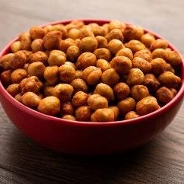

Ingredients
1 x 400g can chickpeas
1 x 15ml spoon (1 tablespoon) olive oil
1 x 5ml spoon (1 teaspoon) paprika
1 x 5ml spoon (1 teaspoon) cumin
Black pepper

Equipment
Colander/sieve, mixing bowl, measuring spoons, mixing spoon, baking tray.

Method
- Preheat the oven to 200°C or gas mark 6.
- Drain and rinse the chickpeas.
- Place the chickpeas in the mixing bowl.
- Add the olive oil, paprika and cumin. Season with black pepper.
- Mix well and pour onto the baking tray.
- Roast in the oven for 30-35 minutes, until golden and crunchy.
- Toss the chickpeas halfway through cooking.
- Remove from the oven and allow to cool.

These are also great if you have an air fryer. Just add the drained and rinsed chickpeas to the basket and spray lightly with oil. Cook for 15 minutes, tossing every five minutes. Add the seasoning five minutes before the end of the cooking time.

Eat well for you and the planet! Top tips
- Focus on fibre – add a handful of almonds to the pan 10 minutes before the end of the cooking time for added fibre.
- Get at least 5 A DAY – add 2 x 15ml spoons (2 tablespoons) dried sultanas, raisins or cranberries to the chickpeas once cooked and cooled.
- Vary your protein – instead of chickpeas, try roasting canned fava beans (or broad beans), black beans or cannellini beans.
- Reduce food waste – this is an ideal way to use up leftover canned beans, particularly when a recipe asks for less than a full can to be used.

