Joel’s Spicy Chicken

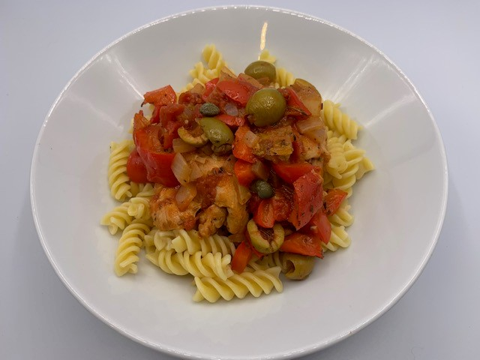
Ingredients
1 red pepper
1 onion
1 garlic clove
100g green olives (canned)
4-6 skinless and boneless chicken thigh fillets
2 x 5ml spoons olive oil
Few sprigs of thyme or 1 x 5ml spoon dried thyme
Sprig of rosemary or 1 x 5ml spoon dried rosemary
1 x 15ml spoon capers
¼ x 5ml spoon chilli flakes (optional)
1 x 15ml spoon balsamic vinegar
400g can chopped tomatoes
1 x reduced salt chicken stock cube
1 bay leaf
75g pasta per person
Black pepper

Equipment
Vegetable knife, chopping board, red board, frying pan, heat proof spoon, plate, casserole dish or oven proof dish with a lid, measuring spoons, measuring jug, large saucepan, colander.

Method
- Preheat the oven to 180°C or gas mark 5.
- Prepare the ingredients:
  - deseed and roughly chop the red pepper;
  - peel and roughly chop the onion;
  - peel and crush or chop the garlic;
  - halve the olives;
  - remove any excess fat from the chicken thighs, remembering to thoroughly wash and dry hands after touching the raw meat.
- Heat 1 x 5ml spoon olive oil in a large frying pan.
- Season the chicken with pepper and place in the frying pan.
- Fry the chicken until golden brown on both slides.
- Remove the chicken to a plate and put to one side.
- Heat the remaining 1 x 5ml spoon olive oil in a casserole dish or oven proof dish.
- Add the chopped pepper and onion. Fry gently for 5 minutes.
- Add the olives, chopped garlic, herbs, capers and chilli flakes (if using).
- Add balsamic vinegar and chopped tomatoes.
- Season with black pepper and stir well.

- Dissolve the stock cube in 500ml boiling water.
- Add the chicken back to the pan and pour over enough stock to cover the chicken. Keep the remaining stock to one side to add later if the sauce becomes too thick during cooking. Add the bay leaf.
- Cover the dish with a lid and place in the oven. Cook for 40 minutes or until the chicken is cooked throughout and no pink meat remains.
- 15 minutes before the chicken is cooked, add the pasta to a pan of boiling water and cook for 10-12 minutes.
- Drain the pasta and serve with the chicken.

Joel’s top tips:
- Use whatever veg is available in the house to cut down on food waste (e.g., courgettes mushrooms or just any veg left over).
- Any cut of chicken would work (e.g. breast) or even another meat like lamb could be used.
- To cut down on food waste, check date labels of food in your fridge/cupboard and use any that is going out of date.

