Recycling signs
Signs like these tell us what packaging can be recycled.

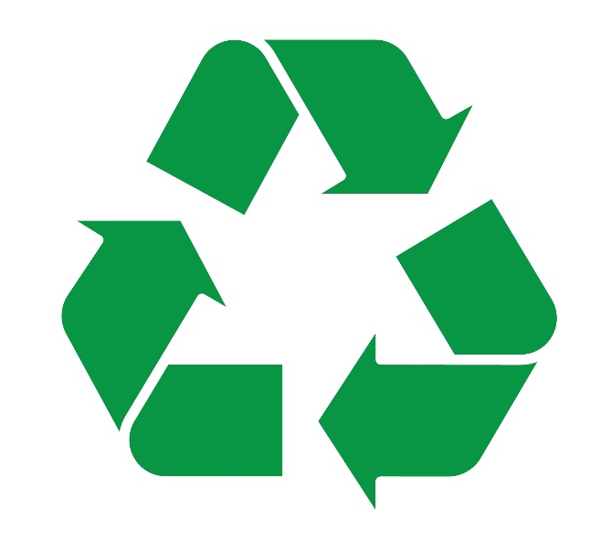

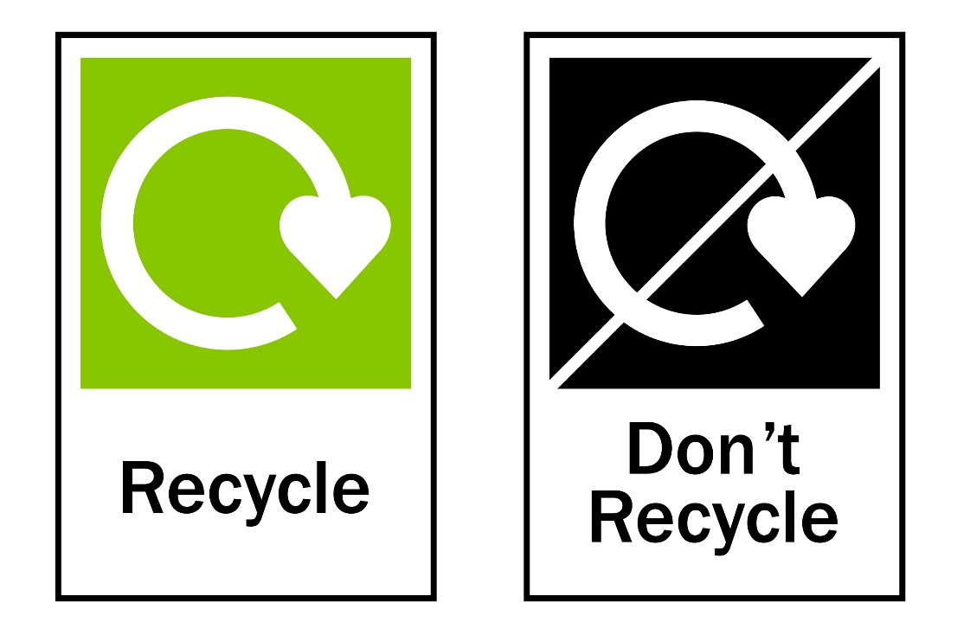

Look out for signs like these on food and drink packaging and remember to recycle!

