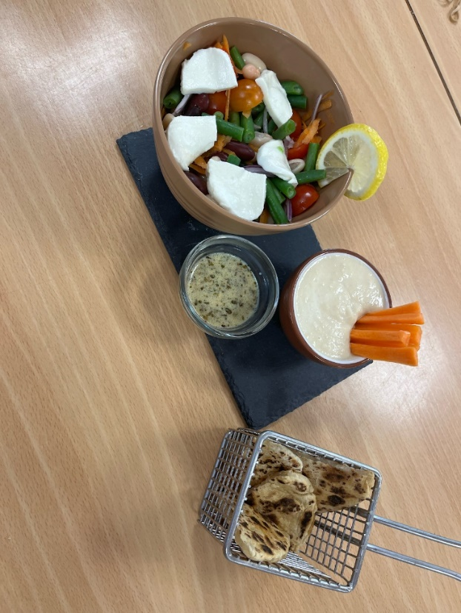
Mixed bean salad served with
a garlic infused flatbread, hummus dip and Dijon dressing

Ingredients
Salad
1 carrot
½ small red onion
100g green beans
½ clove garlic
50g cherry tomatoes
50g red kidney beans
50g cannellini beans
1 ball of reduced fat mozzarella
Hummus
400g can chickpeas
3 x 15ml spoons tahini paste*
1 clove garlic
1 lemon or 2-3 x 15ml spoons lemon juice
from a bottle
2-3 x 15ml spoons water
Black pepper
Flatbreads
100g plain flour (plus a little extra for when rolling out)
100g low fat Greek yoghurt
1 garlic clove
Dressing
20ml olive oil
20ml lemon juice
1 x 5ml spoon Dijon mustard
Black pepper

*Tahini is made from sesame seeds, do not use if allergic to sesame seeds. Greek yogurt can be used instead.

Equipment
Peeler, vegetable knife, chopping board, colander or sieve, small saucepan, lemon juicer, measuring spoons, food processor, mixing bowl, mixing spoon, rolling pin, frying pan, small mixing bowl, large mixing bowl/serving dish.

Method
- Prepare the vegetables for the salad:
  - top and tail, peel and grate the carrot;
  - peel and finely dice the onion;
  - top and tail the green beans, if necessary, and cut in half;
  - peel and crush or chop the garlic;
  - slice the tomatoes in half;
  - drain and rinse the kidney and cannelloni beans;
- Boil 200ml water and add the green beans. Cook for 3-4 minutes or until tender. Once cooked, drain and rinse under cold water to cool.
- Prepare the hummus:
  - drain and rinse the chickpeas;
  - peel and crush the garlic;
  - juice the lemon, if using fresh lemon;
  - place the chickpeas, garlic, lemon juice, tahini and water in a food processor and blitz until smooth.
- Prepare the flatbreads:
  - peel and crush the garlic;
  - place the Greek yogurt, plain flour and garlic in a bowl;
  - season with black pepper and mix until combined and the dough is smooth;
  - knead the dough gently for 1-2 minutes and then divide into 4 even sized balls;
  - on a lightly floured surface, flatten or roll each ball into ovals.
- Heat a frying pan and when hot, dry fry the flatbreads on each side for 2 minutes.
- Make the dressing:
  - peel and crush or chop the garlic;
  - juice the lemon, if using fresh lemon;
  - combine the garlic, olive oil, Dijon mustard and lemon juice in a small bowl. Season with black pepper.
- Assemble the salad:
  - place the kidney beans, cannellini beans, green beans, grated carrot, cherry tomatoes, red onion and garlic in a bowl or serving dish and mix.
- Slice the mozzarella and add to the salad.
- Serve the salad alongside the hummus, dressing and flatbreads.

Top tips
- Add some extra fibre to the flatbreads by swapping half the white flour for wholemeal flour (you may need to use a little more yogurt for the same result!)
- If you don’t have tahini available, you can use Greek yogurt and a little sesame oil to achieve a similar consistency and flavour (if allergic to sesame, just use Greek yogurt to thicken). You could also use a nut butter like cashew or peanut butter (being aware of any peanut or tree nut allergies).
- Why not try different vegetables in the salad? If you’ve got any that might otherwise go to waste, you might want to use those.

