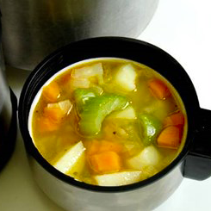
Vegetable Soup
Ingredients
1 onion
1 carrot
1 leek
1 potato
1 celery stick
Spray oil
1 reduced salt vegetable stock cube
600ml boiling water
1 x 15ml spoon (1 tablespoon) coriander
Serves 2

Equipment
Chopping board, knife, vegetable peeler, measuring spoons, saucepan, measuring jug.

Method
- Prepare the vegetables:
  - peel and chop the onion;
  - top and tail, peel and dice the carrot;
  - top and tail, then slice the leek;
  - peel and cube the potato;
  - slice the celery;
  - chop the coriander.
- Spray the saucepan with oil and fry all the vegetables, except the potatoes, for 5 minutes.
- Crumble the stock cube into the pan and pour over the boiling water. Stir well.
- Bring to the boil.
- Add the potatoes and simmer for 20 minutes.
- Stir in the chopped coriander and serve.

Eat well for you and the planet! Top tips
- Focus on fibre – serve your soup with a wholemeal roll or higher-fibre seeded bread.
- Get at least 5 A DAY – swap the potato for a sweet potato to add to your 5 A DAY.
- Vary your protein – include beans or lentils in your soup to add some protein to the dish.
- Reduce food waste – use up any vegetables in your fridge that may otherwise go to waste. Vegetable that have gone wrinkly or become soft are ideal for a soup!

